**Your postcode:**

**Your name:**

**SEED GUARDIAN FRENCH BEAN RETURN FORM 2025**

***This year we are collecting a range of information from Seed Guardians around the country to help us build up a picture of what grows well and where. (This will be a map of plants not people and so we will collate data anonymously). Thank you in advance!***

|  |  |
| --- | --- |
| **Vegetable: French Bean** | **Variety name:** |
| **Soil type**  Clay soils (heavy, high in nutrients, wet and cold in winter and baked dry in summer)  Sandy soils (light, dry, warm, low in nutrients and often acidic)  Silt soils (fertile, light but moisture-retentive, and easily compacted)  Loams (mixtures of clay, sand and silt that avoid the extremes of each type)  Peat soils (very high in organic matter and moisture)  Chalky soils (very alkaline and may be light or heavy) Don’t know | |
| **Where did you grow your plants?**  An outdoor plot in my garden/on my land  An outdoor plot in a shared space e.g. allotment  In a greenhouse  In a polytunnel  In a pot or container outside Somewhere else – please describe: | |
| **Aspect**  South  South West  South East  West  East  North  North West North East | |
| **Height above sea level (m)** | |
| **Any other information about your location that may be useful e.g. coastal, urban etc.** | |
| **Date sown** | |
| **What percentage of the seed you sowed germinated?** | |

**Pod dimensions**

Measure the length (in cm) of 5 immature pods when they have reached their maximum length. If the pods are curved, measure in a straight line from the base to the tip. Record the results below.

|  |  |  |  |  |
| --- | --- | --- | --- | --- |
|  |  |  |  |  |

Measure the width (in cm) of the 5 pods - i.e.the distance across the pod at right angles to the strings. Record the results below:

|  |  |  |  |  |
| --- | --- | --- | --- | --- |
|  |  |  |  |  |

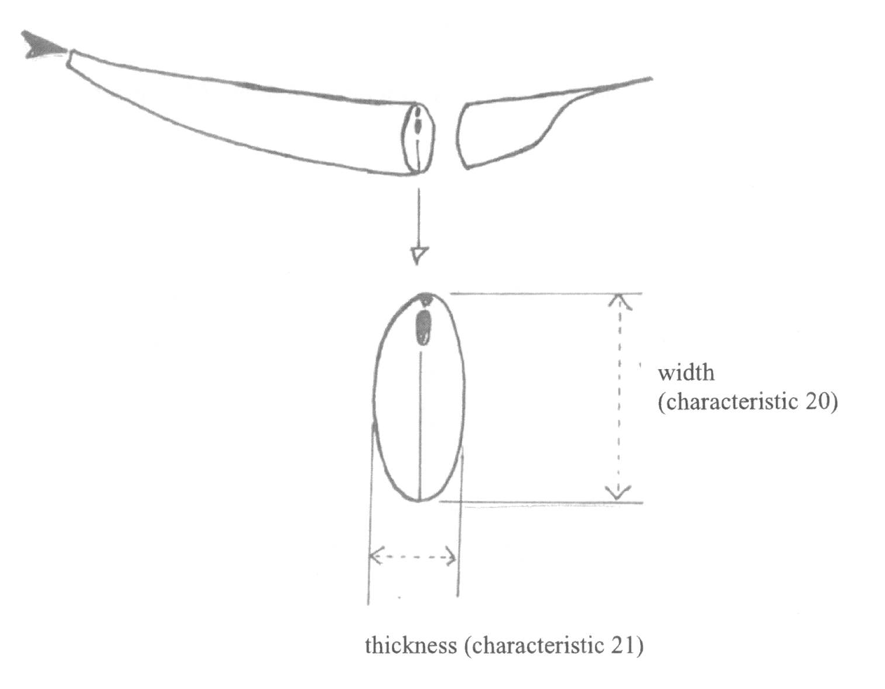

Count the number of seeds in five different pods. Choose long pods from five different plants and record the results below.

|  |  |  |  |  |
| --- | --- | --- | --- | --- |
|  |  |  |  |  |

|  |
| --- |
| **How tall did the plants grow?** |
| **What date did you start to harvest the mature seed?** |
| **How many plants did you save the seed from?** |
| **Did you have any pest or disease problems? If so, how did you counter them and how successful were you?** |

**We would appreciate any comments you could make regarding this variety, eg hardiness, resistance, appearance, taste, recipe ideas etc. Photos are very welcome too. We rely on your input to learn more about the variety so please provide as much information as possible.**

|  |  |
| --- | --- |
| **We would like to understand and recognise how much of your precious time is spent helping us each year and would be grateful if you can provide an approximate number of hours. This figure is used anonymously to collate a total across all guardians around the UK.** |  |

**We like to include creative quotes from members in our published catalogue descriptions. If you’re happy for us to include your comments please confirm:**

**Yes, include my name __________________________________**

**Or, anonymously please**

**We always welcome any photos you take and will be happy to credit you with any we use. You can email them to hsl@gardenorganic.org.uk and do let us know if you would like us to include your name or if no photo credit is needed.**

**THANK YOU FOR COMPLETING THIS RETURN FORM. PLEASE SEND IT TO HSL ALONG WITH YOUR GUARDIAN SEED TO:**

**Seed Guardians, Heritage Seed Library, Ryton Organic Gardens, Coventry, CV8 3LG  
  
*We collect and use your personal information on this form solely for the purpose of seed guardianship activities for the Heritage Seed Library. We will never sell your data and promise to keep your data secure. For more information about how we use the personal information you give us and how to exercise your data protection rights please visit www.gardenorganic.org.uk/privacy-notice or you can request a copy of our privacy notice by contacting us on 02476 308232.***